**Music**: “205-Trailer Hypatios v2” [01:45 min]

* [00:00 – 00:11] **The Hook**
  + Dissolving title card
* [00:11 – 00:23] **Intro**
  + Premise, Mobius Guy animated montage, abstract opening and faint video FPS combat
* [00:23 – 00:34] **Setting**
  + Show Hypatios places, abstract opening, Theratios, WIRED, chambers
* [00:34 – 00:57] **Action**
  + Rapid combat montages, gameplay with UI
* [00:57 – 01:20] **Timekeeper and Lore**
  + 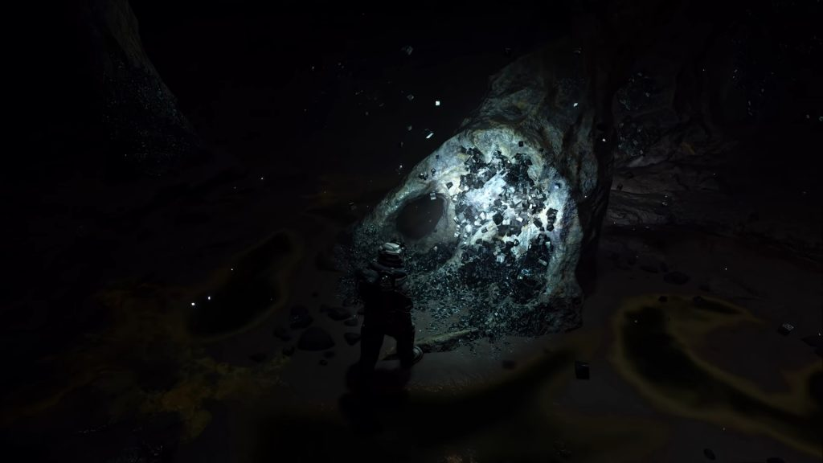
  + [00:57 – 01:07] **“Starfield Montage”** (7 characters or action set piece shown)
    - Starfield’s like Artifact where debris are floating and character montage.
    - HEV soldier smashing a wall using a hammer.
  + [01:09 – 01:20] “**Collateral Dreams**”
    - Vendrich and vision of the future.
    - Timekeeper Testaments.
* [01:20 – 01:45] **Ending**
  + Zoom out of Hypatios Lab. Mobius Corps. Abstract closing.
  + Emperor’s intermezzo 6 sequence.

**TO DO LIST (for 3d stuffs):**

* “**Intro**”
  1. Mobius Guy animated exploring
  2. Mini-chamber side-view
     + Mobius guy player enter and clears the chamber
* “**Setting**”
  1. Noclip camera pans the scene and shows the levels.
* “**Action**”
* .
* ~~Do the “~~**~~Starfield Montage~~**~~” first, the action set pieces and characters (x7 in total. Based per beat).~~
  1. ~~HEV soldier smashing the wall using a hammer.~~
  2. ~~Emperor sitting and relaxing on the couch.~~
  3. ~~Mobius Guards~~
  4. ~~Eastria Spaceguard~~
  5. ~~Planet Sagitarius~~
  6. ~~Theratios flies~~
  7. ~~Fallen Ones/reaper~~
* ~~“~~**~~Collateral Dreams~~**~~” sequence~~
  1. ~~Vendrich and Heavenblazer vague images.~~
  2. ~~Mobius Corps logo.~~
  3. ~~Timekeeper Testaments.~~
  4. ~~WIRED’s heaven server.~~